**1) Create web pages using Basic HTML Tags, Table, List, Image, and Frame Tags.**

**BasicHTMLTags.html**

<html>

<head>

<title>Working on basic tags</title>

</head>

<body>

<p>Web Technologies Lab</p>

<h1>WT</h1>

<h2>CN</h2>

<h3>HCI</h3>

<h4>E-COMM</h4>

<h5>DWDM</h5>

<h6>WT & CN lab</h6>

<hr/>

<p>Working on <b><u>basic</u></b> tags</p>

<p>Working on <strong><i>basic</i></strong> tags</p>

</body>

</html>

**Output:**

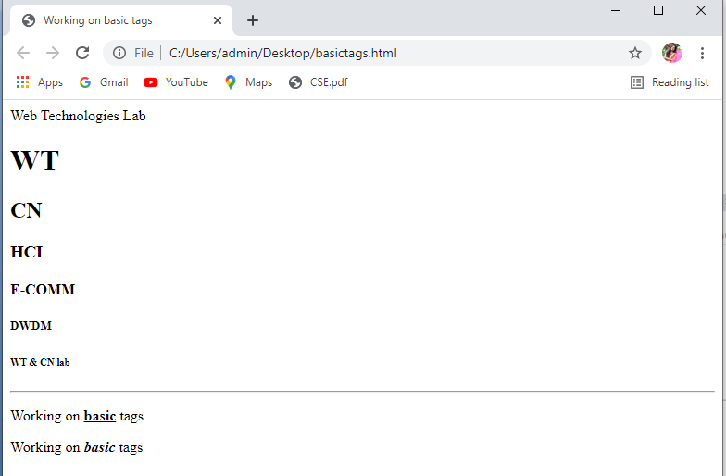

**Tables.html**

<html>

<head>

<title>Working on tables</title>

</head>

<body>

<center>

<h1>Colspan:</h1>

<table border="1">

<tr>

<th>ID</th>

<th>NAME</th>

<th colspan="2">MOBILE</th>

</tr>

<tr>

<td>589</td>

<td>Jyothi</td>

<td>1234567</td>

<td>5678910</td>

</tr>

<tr>

<td>573</td>

<td>siri</td>

<td>3214567</td>

</tr>

<tr>

<td>568</td>

<td>mouni</td>

<td>1234765</td>

<td>5678412</td>

</tr>

<tr>

<td>985</td>

<td>Duffer</td>

<td>1234489</td>

<td>5671234</td>

</tr>

</table>

<hr/>

<h1>Rowspan:</h1>

<table border="1">

<tr>

<th>ID</th>

<td>101</td>

</tr>

<tr>

<th>NAME</th>

<td>puppy</td>

</tr>

<tr>

<th rowspan="2">MOBILE</th>

<td>123456</td>

</tr>

<tr>

<td>678990</td>

</tr>

</table>

</center>

</body>

</html>

**Output:**

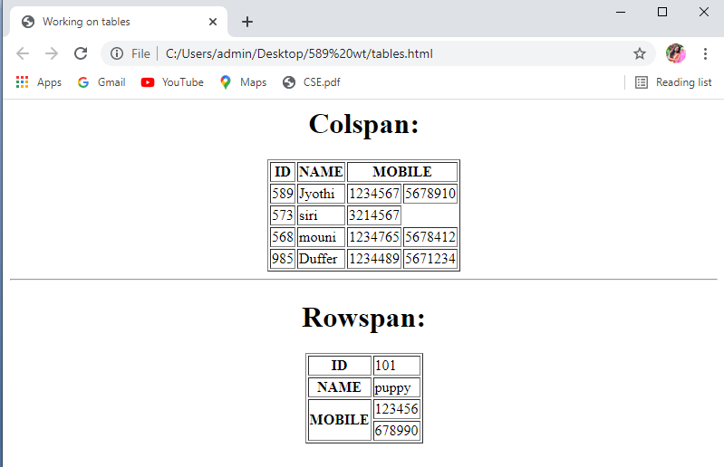

**Lists.html**

<html>

<head>

<title>Working on lists</title>

</head>

<body>

<h1>List concept:</h1>

<h2>unordered lists</h2>

<ul>

<li>rice</li>

<li>wheat</li>

<li>paddy</li>

</ul>

<hr/>

<h2>ordered lists</h2>

<ol>

<li>rice</li>

<li>wheat</li>

<li>paddy</li>

</ol>

<hr/>

<dl>

<dt>HTML</dt>

<dd>hyper text markup language</dd>

</dl>

<hr/>

<h2>Nested lists</h2>

<ol>

<li>Grains

<ul>

<li>rice</li>

<li>wheat</li>

<li>paddy</li>

</ul>

</li>

<li>Fast foods

<ul>

<li>pizza</li>

<li>burger</li>

<li>noodles</li>

</ul>

</li>

</ol>

</body>

</html>

**Output:**

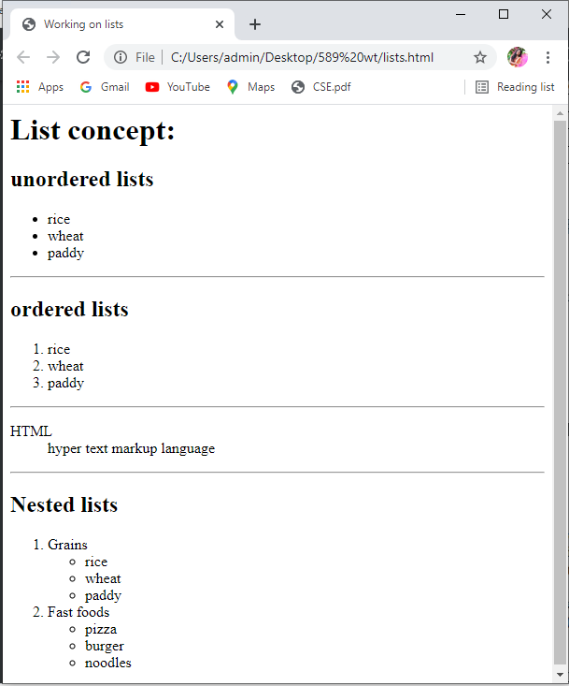

**Imagesandlinks.html**

<html>

<head>

<title>IMAGES AND LINKS</title>

</head>

<body>

<p>CONCEPT OF LINKS</p>

<a href="https://www.w3schools.com">W3 Schools</a><br/>

<a href="tags.jpg"><img src="html.png" alt="HTML image should be there here" width="200" height="200"></a>

</body>

</html>

**Output:**

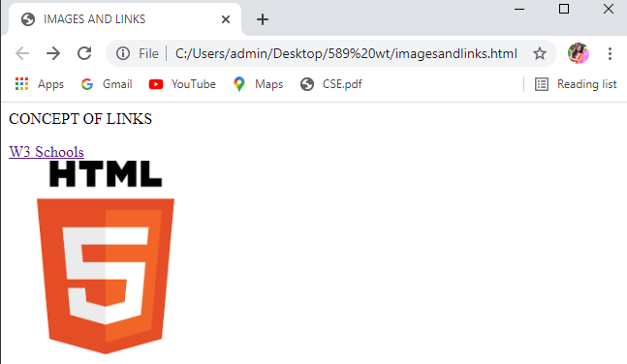

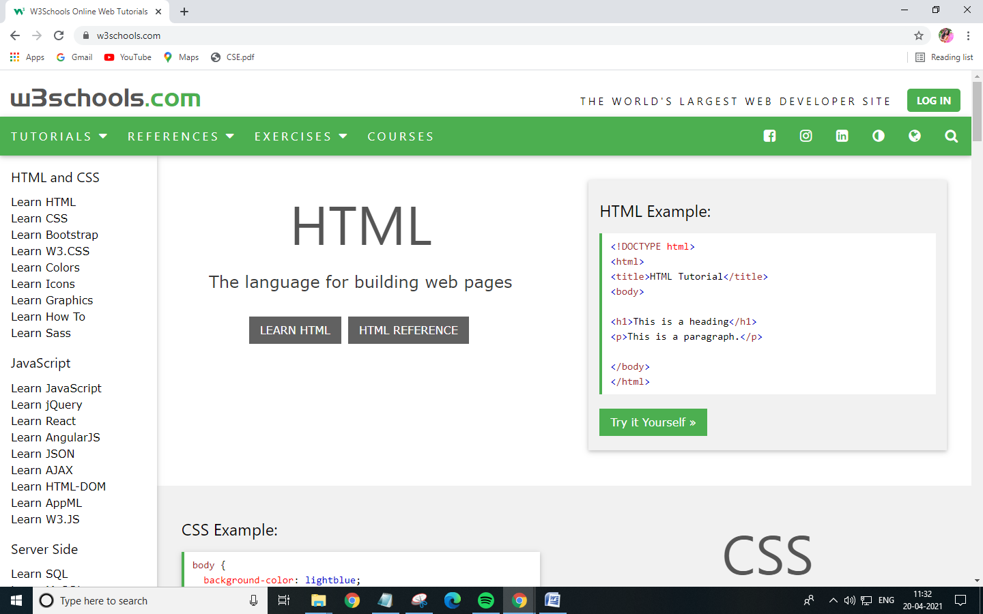

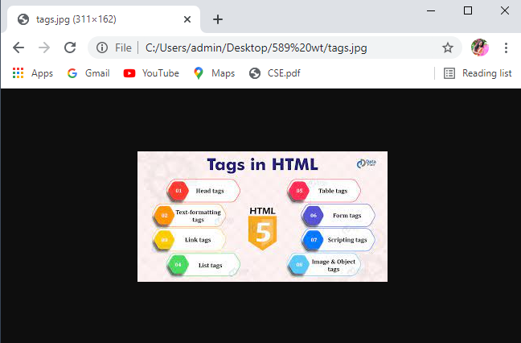

**Frames.html:**

<html>

<head>

<title>Working with frames</title>

</head>

<frameset rows="20%,70%,10%">

<frame src="Topframe.html"/>

<frameset cols="20%,80%">

<frame src="Middleframe.html"/>

<frame src="Rightframe.html" name="Rightframe"/>

</frameset>

<frame src="Bottomframe.html"/>

</frameset>

</html>

**Topframe.html**

<html>

<head>

<title>Working with frames</title>

</head>

<body>

<h1 align="center">Aditya Engineering College</h1>

</body>

</html>

**Output:**

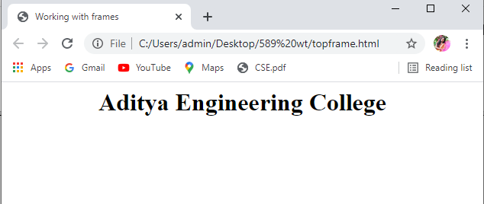

**Middleframe.html**

<html>

<head>

<title>Working with frames</title>

</head>

<body>

<a href="BasicTags.html" target="Rightframe">Basic Tags</a><br/>

<a href="Imagesandlinks.html" target="Rightframe">Images and Links</a><br/>

<a href="Tables.html" target="Rightframe">Tables</a>

</body>

</html>

**Output:**

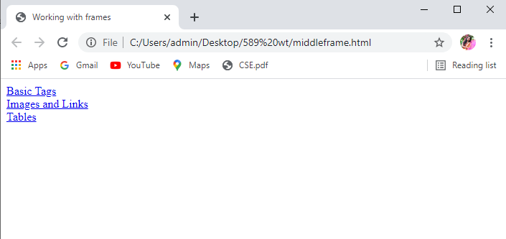

**Rightframe.html**

<html>

<head>

<title>Working with frames</title>

</head>

<body>

<h1 align="center">Output</h1>

</body>

</html>

**Output:**

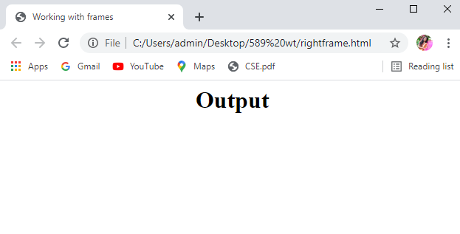

**Bottomframe.html**

<html>

<head>

<title>Working with frames</title>

</head>

<body>

<h1 align="center">@copyrights</h1>

</body>

</html>

**Output:**

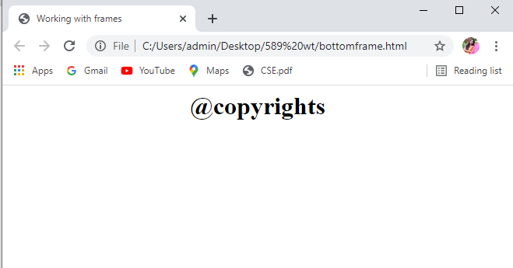

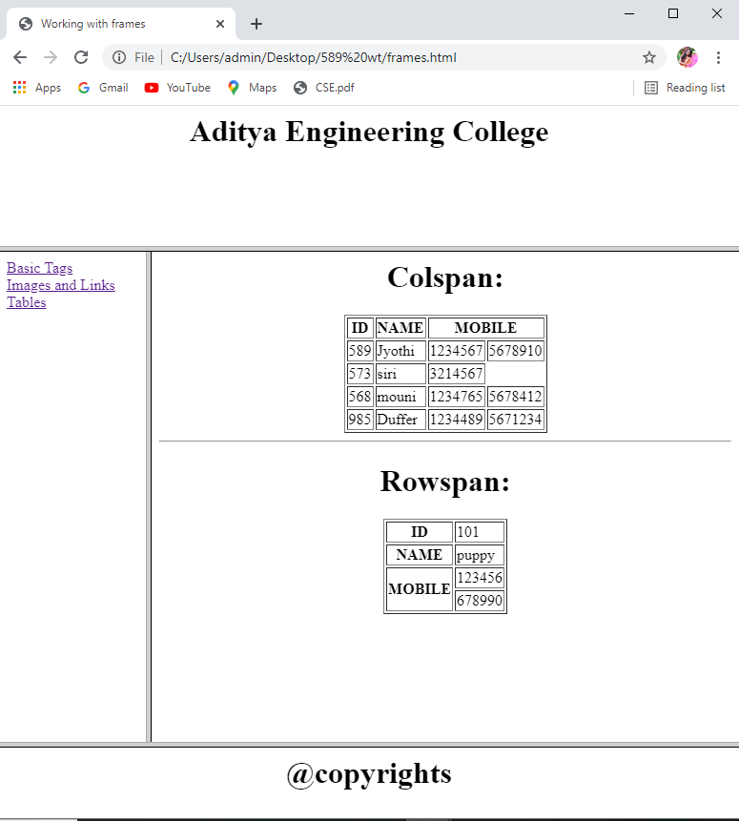

**2) Using Form Tags.**

**2.1)Create a Login form.**

<html>

<head>

<title>Login Page</title>

</head>

<body bgcolor="AliceBlue">

<form action="validate.php" method="post">

<table align="center">

<tr>

<td>Login</td>

<td><input type="text" name="login" size="20"

maxlength="20"value=""></td>

</tr>

<tr>

<td>Password</td>

<td><input type="password" name="pwd"

size="20"maxlength="20"></td>

</tr>

<tr valign="middle">

<td><input type="submit" value="submit"></td>

<td><input type="reset"></td>

</tr>

</table>

</form>

</body>

</html>

**Output:**

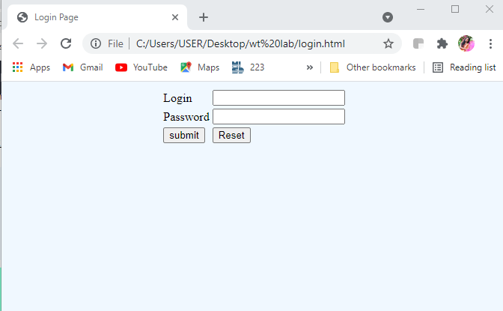

**2..2)Create a “registration form” with the following fields a) Name (Text field) ;b) Password (password field); c) E-mail id (text field); d) Phone number (text field) ;e) Sex (radio button); f) Date of birth (3 select boxes); g) Languages known (check boxes – English, Telugu, Hindi, Tamil) ;h) Address (text area)**

<html>

<head>

<title>Registration Page</title>

</head>

<body bgcolor="pink">

<center>

<h3 align="center"><u>Registration Form</u></h3>

<table border="3">

<tr>

<td><form name="f1" action="" method="post" onsubmit="">

<table cellspacing="10" cellpadding="5">

<tr><td>Name</td><td><input type="text" name="Name" size="20" maxlength="20"

value=""></td></tr>

<tr><td>Password</td><td><input type="password" name="pwd" size="20"

maxlength="20"></td></tr>

<tr><td>Email id</td><td><input type="text" name="mail id" size="20" maxlength="20"

value=""></td></tr>

<tr><td>Phone Number</td><td><input type="text" name="no" size="20" maxlength="20"

value=""></td></tr>

<tr><td>Sex</td><td><input type="radio" name="Gender" value="male">Male

<input type="radio" name="Gender" value="female">Female</td></tr>

<tr><td>Date of birth</td><td><select>

<option>DD<option>01<option>02<option>03<option>04<option>05<option>06

<option>07<option>08<option>09<option>10<option>11<option>12<option>13

<option>14<option>15<option>16<option>17<option>18<option>19<option>20

<option>21<option>22<option>23<option>24<option>25<option>26<option>27

<option>28<option>29<option>30<option>31</select>

<select>

<option>MM<option>01<option>02<option>03<option>04<option>05<option>06

<option>07<option>08<option>09<option>10<option>11<option>12 </select>

<select>

<option>YYYY<option>1999<option>2000<option>2001<option>2003<option>2004

<option>2005 <option>2006<option>2007<option>2008<option>2009<option>2010

<option>2011<option>2012<option>2013<option>2014<option>2015<option>2016

<option>2017 <option>2018<option>2019 <option>2020 <option>2021 </select>

<tr><td>Languages Known</td><td><input type="checkbox" name="Language"

value="English">English

<input type="checkbox" name="Language" value="Telugu">Telugu

<input type="checkbox" name="Language" value="Hindi">Hindi

<input type="checkbox" name="Language" value="Tamil">Tamil</td></tr>

<tr><td>Address</td><td><textarea name="Address" rows="5" cols=25"></textarea>

<tr valign="middle"><td><input type="submit" value="submit"></td>

<td><input type="reset"></td></tr>

</tr>

</table>

</center>

</table>

</form>

</body>

</html>

**Output:**

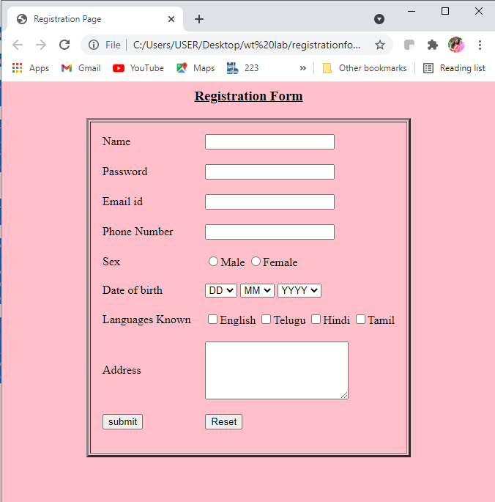

**3) CSS & Java Script**

**3.1) Design a web page using CSS (Cascading Style Sheets) which includes the following: 3.1.1) Use different font, styles: In the style definition you define how each selector should work (font, color etc). Then, in the body of your pages, you refer to these selectors to activate the styles.**

**Style.css**

h1

{

color:red;

font-family:caStellar;font-size:22pt;

text-decoration:underline;

}

h2

{

color:blue;

font-family:Chiller;font-size:18pt;

text-decoration:overline;

}

p

{

color:magenta;

font-family:Trebuchet MS;font-size:14pt;

font-style:italic;

}

**31.html**

<html>

<head>

<title>Usage of different font,styles and colors</title>

<link rel="stylesheet" type="text/css" href="styles.css"/>

</head>

<body>

<h1>This header is in red</h1>

<h2>This header is in blue</h2>

<p>This is normal text</p>

</body>

</html

**Output:**

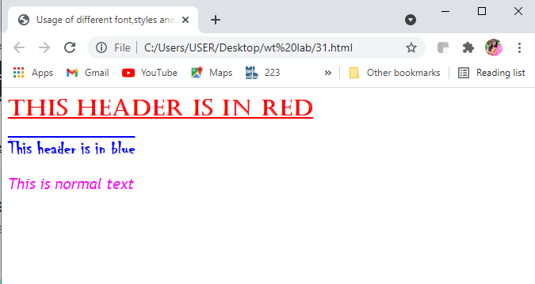

**3.1.2) Set a background image for the web page and control the repetition of the image with the background-repeat property.**

<html>

<head>

<title>Controlling background image</title>

<style type="text/css">

body

{

background-image:url("bg.png");

background-repeat:no-repeat

}

</style>

</head>

<body text="#8A2BE2">

<h1>Life is beautiful!!!</h1>

</body>

</html>

**Output:**

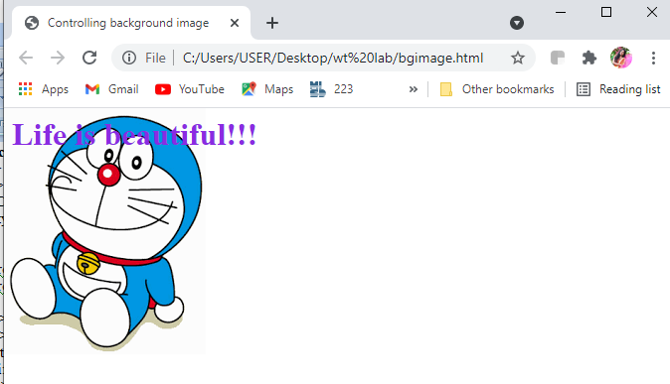

**3.1.3) Define styles for link as visited, active, hover & link.**

<html>

<head>

<h1 align="center">Web Page using CSS</h1>

<style type="text/css">

Body

{

background-image:url(pikachu.jpg);

background-repeat:repeat-y;

}

P

{

color:black;

font-size:20pt;

font-family:chiller;

background-image:url(bg.png);

}

a:link

{

font-size:20pt;

background-color:white;

}

a:hover

{

font-size:20pt;

background-color:pink;

cursor:crosshair;

}

a:active

{

font-size:20pt;

background-color:cyan;

cursor:help;

}

a:visited

{

font-size:20pt;

background-color:tan;

}

</style>

</head>

<title>CSS Webpage!!!</title>

<body><br>

<p>Welcome to Web page using CSS where CSS means Cascading Style Sheets!

Using CSS we can apply the common styles to different tags and

also different styles to same tag ie repeated more than once in the html file</p>

<a href="registrationform.html"><center>Register</center></a>

<br><br><br><br><br><br><br><br><br>

</body>

</html>

**Output:**

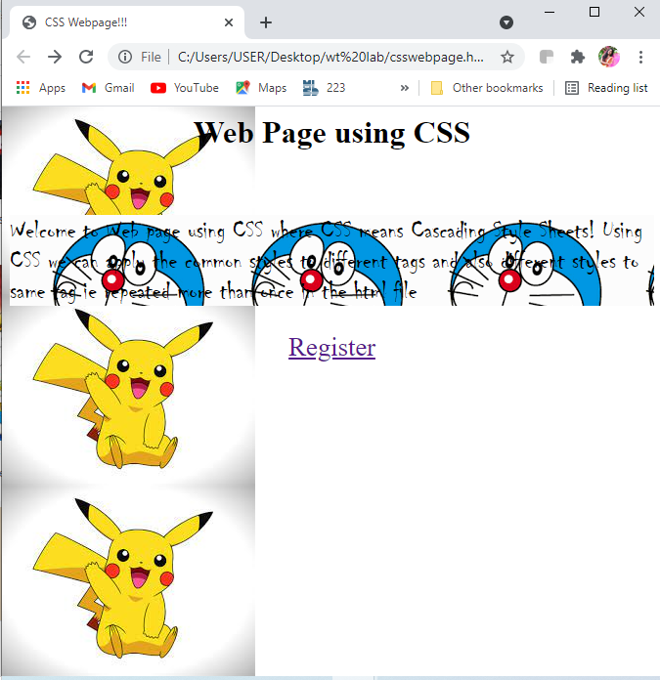

**3.2) Write a JavaScript that takes a number from one text field in the range of 0-999 and display it in other text field in words. If the number is out of range, it should show “out of range” and if it is not a number, it should show “not a number” message in the result box.**

<script language="javascript">

function convert_number_to_words(number)

{

hyphen='-';

conjunction='and';

separator='.';

dictionary={0:'zero',1:'one',2:'two',3:'three',4:'four',5:'five',6:'six',7:'seven',8:'eight',

9:'nine',10:'ten',11:'eleven',12:'twelve',13:'thirteen',14:'fourteen',15:'fifteen',16:'sixteen',

17:'seventeen',18:'eighteen',19:'nineteen',20:'twenty',30:'thirty',40:'fourty',50:'fifty',

60:'sixty',70:'seventy',80:'eighty',90:'ninety',100:'hundred',};

if(number<0 || number>999)

{

alert("enter a number range between 0 and 999");

return "";

}

switch(true)

{

case(number<21):

string=dictionary[number];

break;

case(number<100):

tens=parseInt(number/10)*10;

units=number%10;

string=dictionary[tens];

if(units){

string+=hyphen+dictionary[units];

}

break;

case(number<1000):

hundreds=parseInt(number/100);

remainder=number%100;

string=dictionary[hundreds]+ ' ' +dictionary[100];

if(remainder){

string+=conjunction+convert_number_to_words(remainder);

}

break;

default:

break;

}

return string;

}

a=prompt("Enter a number");

num=parseInt(a);

document.write(convert_number_to_words(num));

</script>

**Output:**

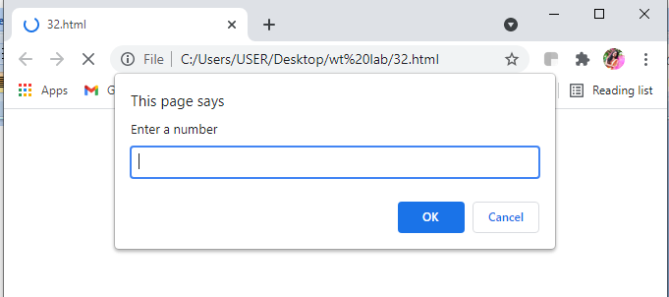

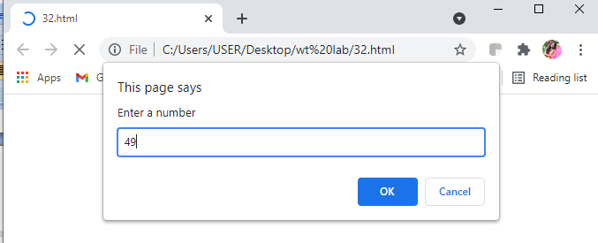

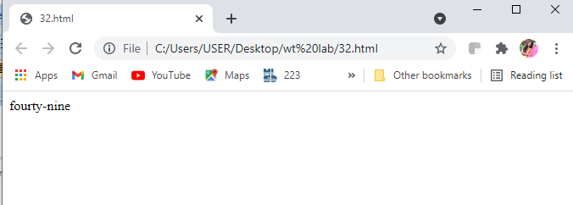

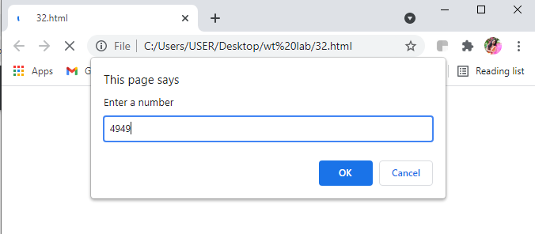

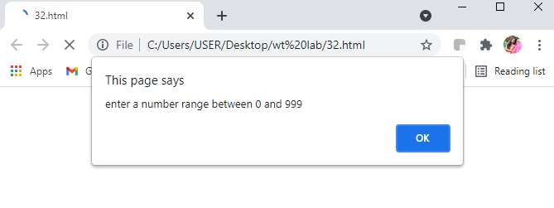

**4) Java Script & XML**

**4.1) Write a JavaScript to validate the following fields in a registration page created in week 2 a. Name (start with alphabet and followed by alphanumeric and the length should not be less than 6 characters) b. Password (it allows alphanumeric, special symbols and should not be less than 6 characters) c. E-mail (should not contain invalid email addresses)**

<html>

<head>

<h1 align=center>

Welcome to Validation Checking

</h1>

<hr width=50%>

<script language="javascript">

function validation()

{

var x=f.un.value;var len=x.length;

var val=x.charCodeAt(0); var p=f.pw.value;

var c=f.cpw.value;var a=f.email.value;

var atpos=a.indexOf("@");var dotpos=a.lastIndexOf(".");

if(len<6||x==""||x==null)

{

alert("check your username! must be minimum 6 characters");

}

else if(val<65 || val>90&&val<97 || val>122)

{

alert("username must be begin with an alphabet");

return fasle;

}

else if(p==" || c==" || p.length<6 || c.length<6 || p!=c)

{

alert("password and confirm password should be same and greater than 6 characters!");

return false;

}

else if(atpos<6 || dotpos<atpos+6 || dotpos+2>=a.length)

{

alert("Not a Valid email id");

return false;

}

else

alert("Congratulations!you have submitted successfully");

}

</script>

</head>

<body>

<table align=center border=I>

<form name="f" action="success.html" onsubmit="return validation();" method="post">

<tr>

<td>User Name:</td>

<td><input type="text" name="un"/></td>

</tr>

<tr>

<td>Password:</td>

<td><input type="password" name="pw"/></td>

</tr>

<tr>

<td>Confirm Password:</td>

<td><input type="password" name="cpw"/></td>

</tr>

<tr>

<td>E-mail ID:</td>

<td><input type="text" name="email"/></td>

</tr>

<tr>

<td></td>

<td><input type="Submit" name="Submit"/></td>

</tr>

</form>

</table>

</body>

</html>

**Output:**



**4.2) Write an XML file which will display the Book information which includes the following: a) Title of the book ;b) Author Name ;c) ISBN number ;d) Publisher name e) Edition ;f) Price Write a Document Type Definition (DTD) to validate the above XML file and display the details in a table (to do this use XSL).**

**book.dtd:**

<!ELEMENT bookdetails(books+)>

<!ELEMENT books(title,author,isbn,publisher,edition,price)>

<!ELEMENT title(#PCDATA)>

<!ELEMENT author(#PCDATA)>

<!ELEMENT isbn(#PCDATA)>

<!ELEMENT publisher(#PCDATA)>

<!ELEMENT edition(#PCDATA)>

<!ELEMENT price(#PCDATA)>

**book.xml:**

<?xml version="1.0"?>

<!DOCTYPE bookdetails SYSTEM "book.dtd">

<?xml-stylesheet type="text/xsl" href="book.xsl"?>

<bookdetails>

<books>

<title>C</title>

<author>Balaguruswamy</author>

<isbn>123456</isbn>

<publisher>Oxford</publisher>

<edition>Edition-II</edition>

<price>$30.00</price>

</books>

<books>

<title>C++</title>

<author>yaswanth kanethkar</author>

<isbn>654321</isbn>

<publisher>Tata McHill</publisher>

<edition>Edition-I</edition>

<price>$35.00</price>

</books>

<books>

<title>JAVA</title>

<author>Herbert Schildt</author>

<isbn>789456</isbn>

<publisher>Cenage</publisher>

<edition>Edition-IV</edition>

<price>$50.00</price>

</books>

</bookdetails>

**book.xsl:**

<?xml version="1.0"?>

<xsl:stylesheet version="2.0" xmlns:xsl="http://www.w3.org/1999/XSL/Transform">

<xsl:template match="/">

<html>

<head>

<center>Book Details</center>

</head>

<body>

<hr width="50%"/>

<table border="1" align="center">

<tr>

<th>TITLE</th>

<th>AUTHOR</th>

<th>ISBN</th>

<th>PUBLISHER</th>

<th>EDITION</th>

<th>PRICE</th>

</tr>

<xsl:for-each select="bookdetails/books">

<tr>

<td><xsl:value-of select="title"/></td>

<td><xsl:value-of select="author"/></td>

<td><xsl:value-of select="isbn"/></td>

<td><xsl:value-of select="publisher"/></td>

<td><xsl:value-of select="edition"/></td>

<td><xsl:value-of select="price"/></td>

</tr>

</xsl:for-each>

</table>

</body>

</html>

</xsl:template>

</xsl:stylesheet>

**Output:**

